1. Buy now button shown instead of Sign in which is little confusing/ Login shown at bottom of page
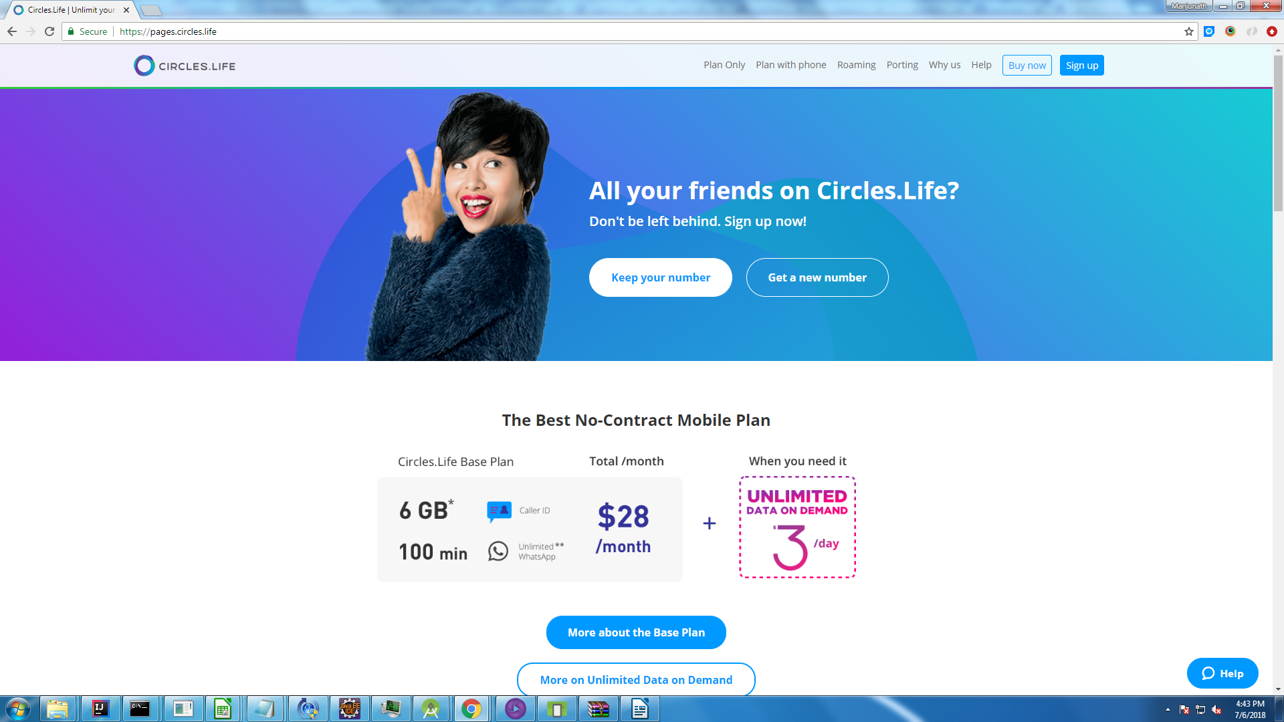

2. Once the user sign in , Header with options to navigate to Home, My orders, My Account , Logout etc is not shown (Issue is inconsistent)
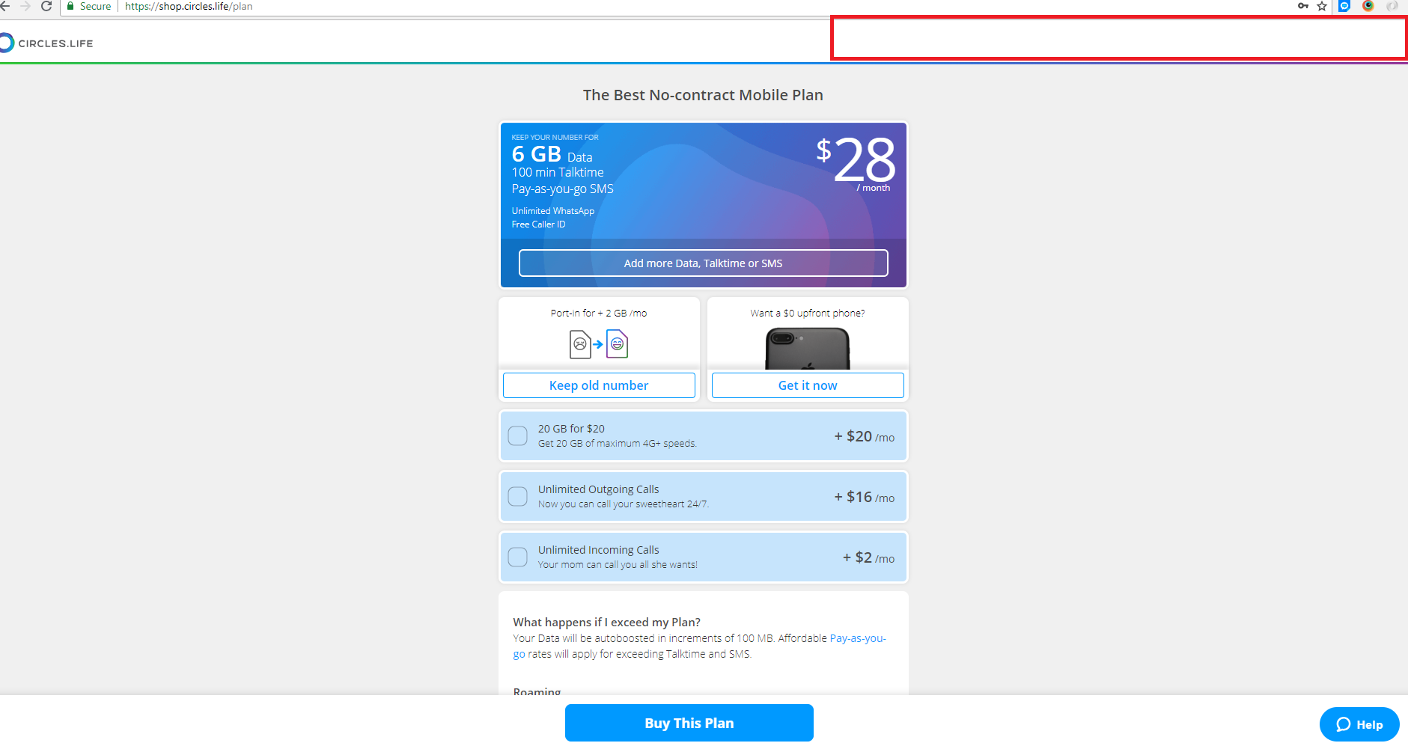

3. Sign up shown in new tab opened when logged in user Click on About us/pay as you go etc hyper links in home page
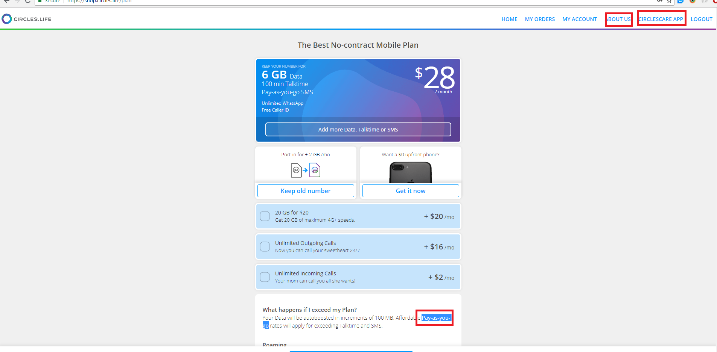

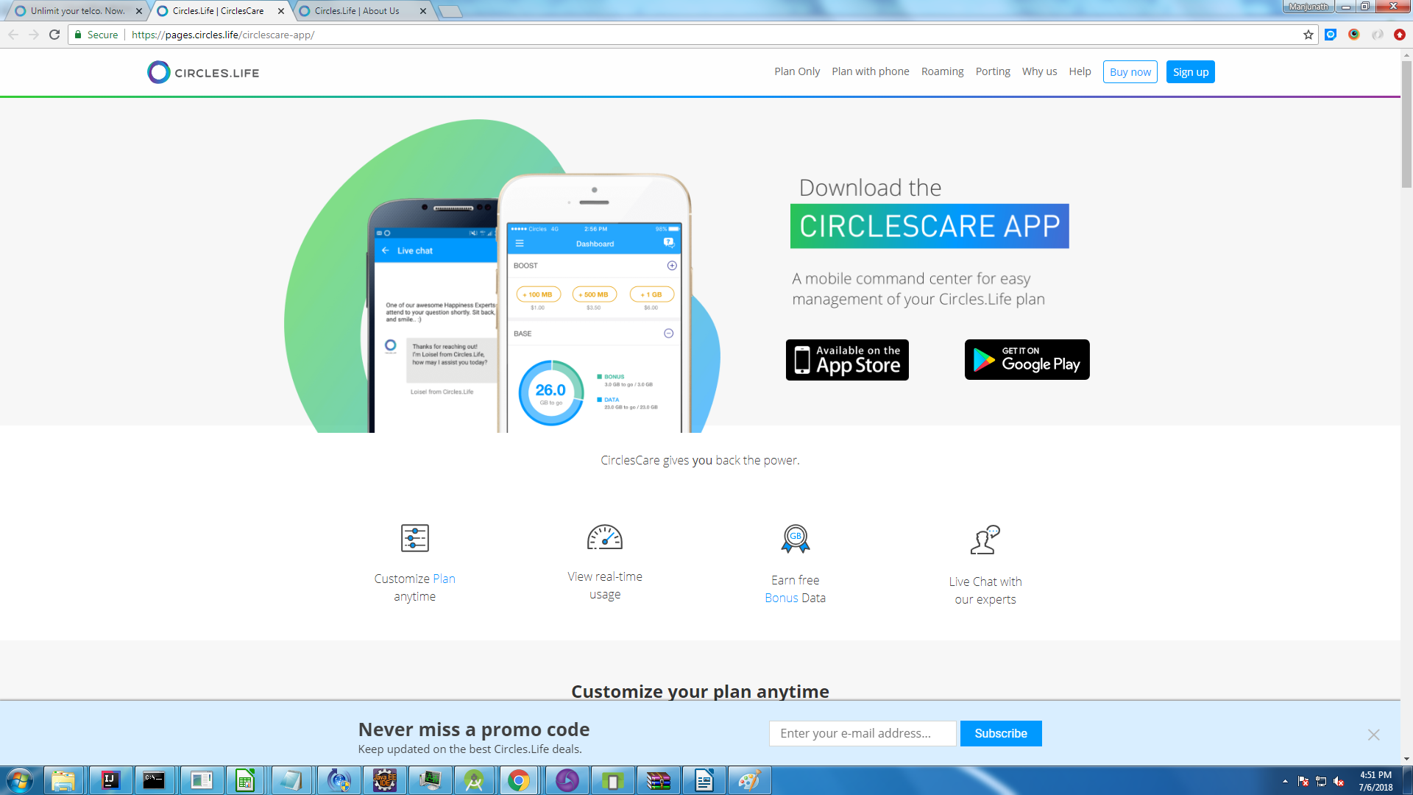

4. Multiple warning message displayed
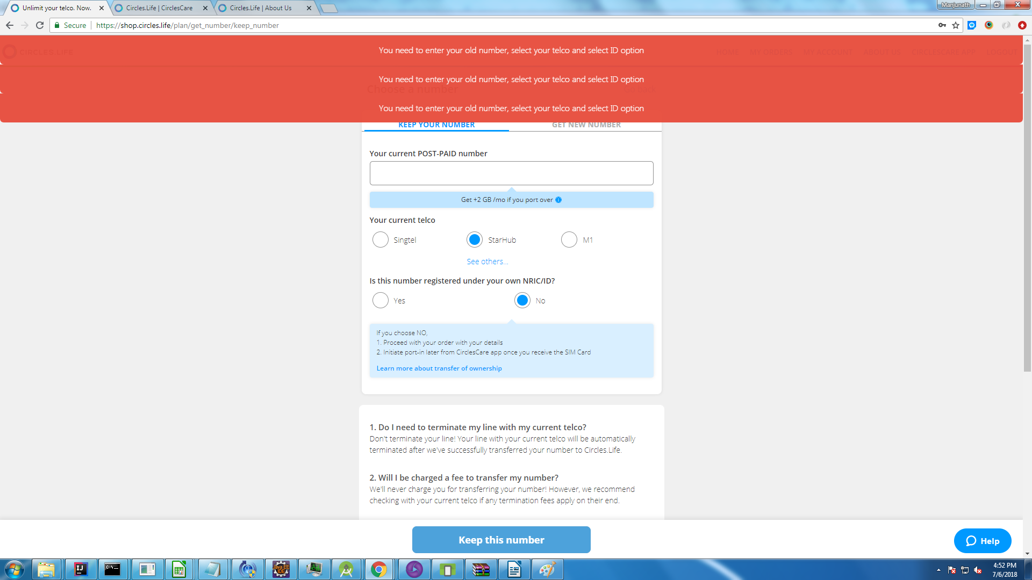

5.

